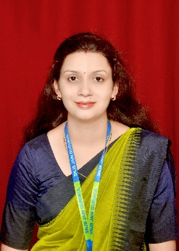SNJB’s S.H.H.J.B. Polytechnic, Chandwad

Department: Electronics and Tele-Communication Engineering

**Faculty Profile**

**Mrs. Bairagi Lajima Shubham**

|  |  |
| --- | --- |
| Qualification : | B.E (E&TC) |
| Designation : | Lecturer |
| Date of Joining : | 01-July-2024 |
| Experience : | 6 Months |
| Teaching/research Areas : | Industrial Automation, PLC, SCADA, Python, Embedded System, Power Electronics, Microcontroller , Arduino, Node MCU, GSM, GPS |
| Courses / Subjects Involved With : | EJ3K- Basic Python Programming (BPP-313011)  EJ5I- Industrial Automation (IAU-22534)  EJ5I- Embedded System PR (ESY- 22532) |
| Staff training/FDP attended in last 3 years | FDP on “Emerging Treands In Electrical Engineering” Organized by institute Shivjirao S. Jondhale Polytechnic, Asangaon.  FDP on “Understanding Ev Technology: Current Trends And Future Prospect” Organized by institute Brahmdevdada Mane Polytechnic, Belati, Solapur. |
| List of Projects guided at diploma level last 3 years | Onion Health Monitoring  Robotic Home Cleaner |
| Paper presentation /conferences attended | N/A |
| Paper published in journals/ Magazines | Graphene Super Capacitor (Electro-Nation Magazine February-2021)  Thermal Copper Pillar Bump (Electro-Nation Magazine September-2021) |
| Books published with ISSN/ISBN  number : | N/A |
| Role and responsibilities at institute  level | N/A |
| Role and responsibilities at department level | Departmental Library Coordinator  Feedback Coordinator  Criteria 7 Coordinator  Antiragging Co-ordinator |
| Major achievements in last 5 years | - |
| Professional membership if any | N/A |
| Additional information | Nil |